🔥 Mastering Wildcards in Linux: The Power of Pattern Matching
If you’ve ever worked with the Linux command line, you’ve probably faced situations where typing out every file name feels… painful. That’s where wildcards come in — tiny symbols with superpowers. They let you match multiple files, automate repetitive tasks, and work faster than ever.
In this blog, we’ll explore what wildcards are, how they work, and how you can use them like a pro.

🌟 What Are Wildcards?
Wildcards are special characters used in Linux shell commands to match patterns instead of specific filenames. Think of them as flexible placeholders that expand into real file names behind the scenes.

They’re mainly used with commands like:
- ls
- cp
- mv
- rm
- cat

…and many others.

🃏 Types of Wildcards in Linux
Let’s explore the main wildcards with examples you can try right away

1. ⭐ The Asterisk * — The “Match Anything” Hero
- Matches zero or more characters — meaning it can match empty strings or very long filenames.
- Great for broad selections like file types (*.txt) or similar prefixes (log*).
- Very powerful but risky — a careless * in commands like rm can delete more than intended.

✔ Examples:

· ls *.txt — Shows all files ending with .txt . Here by entering the command we can see all the files we have created.

· rm file* — Removes all files starting with file . Here by entering the command we have removed all the files.
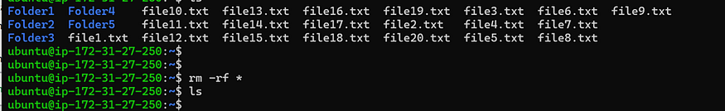

2. ❓ The Question Mark ? — The “Match Just One Character”

- Replaces one unknown character, making it ideal for fixed-length filenames.
- Useful for structured files like img1.jpg, img2.jpg, where you know the position of variations.
- Safer than *, because it limits the number of matched files.

✔ Examples:

· ls file?.txt — file1.txt, fileA.txt, file.txt. Here we used command to see all the files specifically in single character file name and double character file name separately.
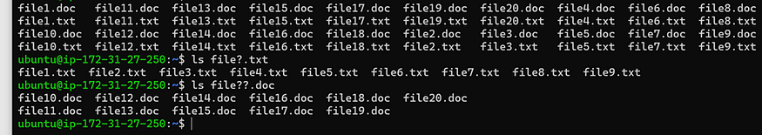

· rm file?.txt — file11.txt, file12.txt… Here we used commands to delete double character files ending with .txt as you seen below.
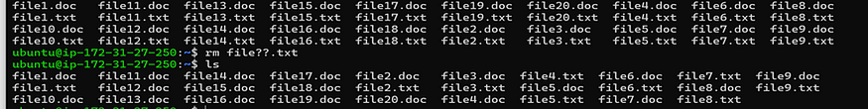

- 🔤 Brackets [] — The Character Pickers

- Let’s you define specific character sets, e.g., [abc] matches only a, b, or c.
- Supports numeric and alphabetic ranges, like [1-5] or [A-Z].
- Great for grouped selections, such as file [1-3].txt or [aeiou]* for vowel-starting filenames.

✔ Examples:

· ls file [1–3].txt — file1.txt, file2.txt, file3.txt

· ls file [1–4].doc — file1.doc, file2.doc, file3.doc

🔍Where Wildcards Help Most

· Bulk file operations
· Searching and filtering files
· Automation and scripting
· Log file management (useful in SOC, DevOps)

⚠️Safety Tip:
· Be careful with rm + wildcard!
· rm -rf * — removes everything
· This removes all files in current directory ⚠️
· Always double-check before executing commands!

🎯 Final Thoughts
Wildcards in Linux are one of those small things that dramatically improve your workflow. Once you get used to them, the command line feels much less intimidating and a lot more empowering. Whether you’re managing huge log directories, cleaning up your workspace, or automating routine tasks, wildcards are your silent helpers.

